CYBERSECURITY TOOLS · WEEKLY LEARNING TRACK
Nmap Reference Documentation
Target Specification & Host Discovery (Complete)

Prepared by Emmanuel Aidoo
Kali Linux · Nmap 7.98
September 14–16, 2026

Contents
1 Single IP Address Scan 3
2 Multiple Host Scanning 4
3 CIDR Range Scan 5
3a Host Discovery Techniques (-sn and -Pn) 6
3b Enumerating Targets Only (-sL / List Scan) 7
4 Verbose Scan & Timing Behaviour 9
5 Key Takeaways 10

Objective:To get comfortable with how Nmap accepts targets, from a single IP up through a full CIDR range, and see what its scan phases and timing engine actually look like in practice.
Topic: single-IP scanning, multi-host scanning, CIDR ranges, host discovery (-sn, -Pn, -sL), and Nmap's internal scan phases and timing behaviour.

1 Single IP Address Scan
$ nmap 173.230.138.70
What I learned
A scan against one target IP with default Nmap settings (SYN scan, top 1000 ports).
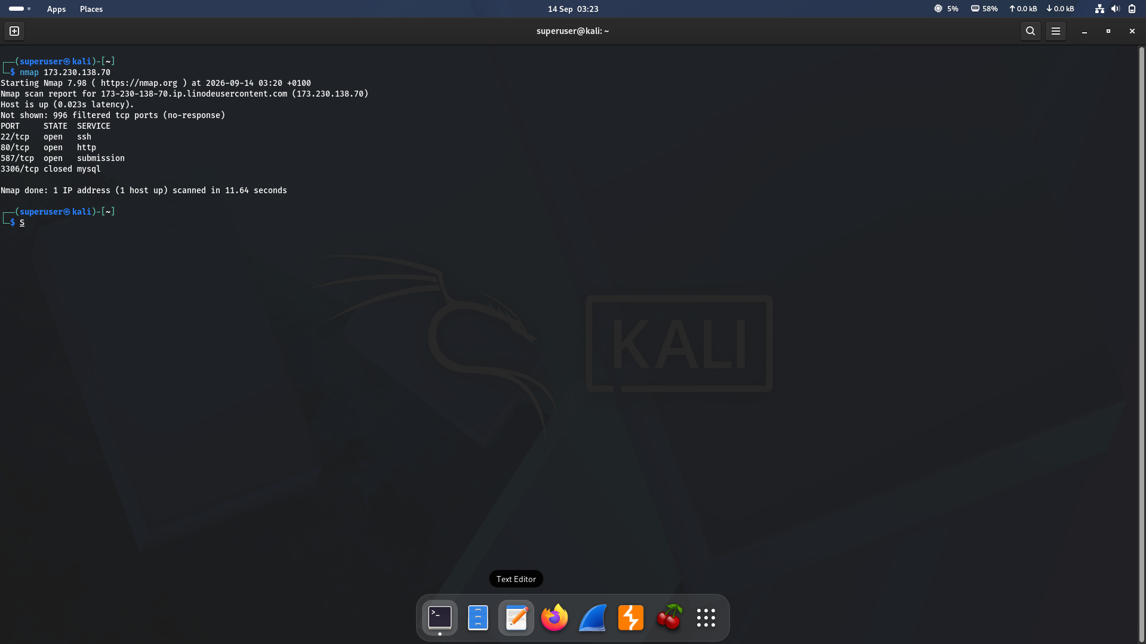
Figure 1 · Default scan of a single host (173.230.138.70)
Result summary
Port | State | Service
22/tcp | open | ssh
80/tcp | open | http
587/tcp | open | submission
3306/tcp | closed | mysql

My observation
996 of the 1000 scanned ports were filtered (no response). The host resolved to 173-230-138-70.ip.linodeuscontent.com, confirming it's a Linode-hosted server. Total scan time: 11.64 seconds.

2 Multiple Host Scanning
$ nmap 8.8.8.8 173.230.138.70
What I learned
Nmap accepts more than one target in a single invocation. I just have to separate them with spaces. Each target is scanned independently and reported in its own block.
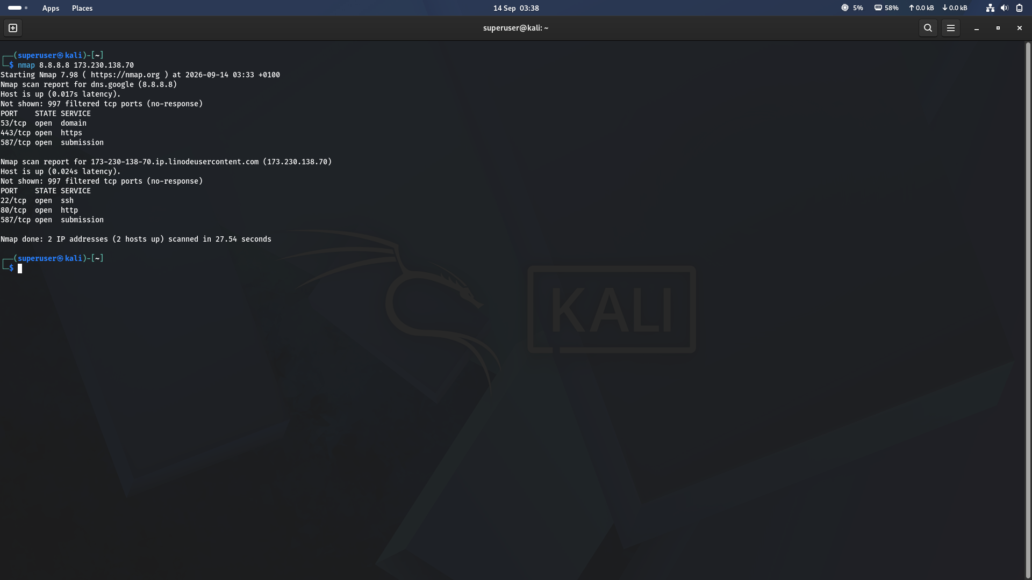
Figure 2 · Scanning two unrelated hosts in one command
Result summary
Host | Open Ports | Notes
8.8.8.8 (dns.google) | 53, 443, 587 | Google public DNS resolver
173.230.138.70 | 22, 80, 587 | Same Linode host as Section 1

My observation
Nmap ran the two scans back-to-back and reported “2 IP addresses (2 hosts up) scanned in 27.54 seconds”. Roughly double the time of the single-host scan, since each target still gets its own full port probe.

3 CIDR Range Scan
$ nmap 10.0.2.15/24
What I learned
Appending a CIDR suffix (e.g. /24) tells Nmap to expand the target into every address in that subnet and scan each one that responds. This is the fastest way to sweep a whole local network.
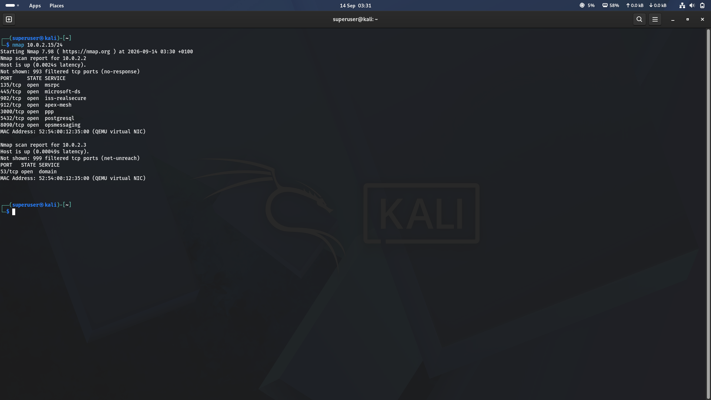
Figure 3 · CIDR sweep of the 10.0.2.0/24 lab network
Result summary
Host | Open Ports | Notes
10.0.2.2 | 135, 445, 902, 912, 3000, 5432, 8090 | Likely the VMware/VirtualBox NAT gateway — a wide service mix (RPC, SMB, VMware tools, Postgres) is typical of the host machine's NAT interface, not a real endpoint
10.0.2.3 | 53 (domain) | The NAT DNS relay provided by the hypervisor

My observation
Both hosts share the same MAC address (52:54:00:12:35:00), confirming they're virtual interfaces on the same QEMU/KVM NAT segment rather than separate physical machines.

3a Host Discovery Techniques (-sn and -Pn)
$ nmap -sn 10.0.2.15/24
What I learned
The -sn flag tells Nmap to skip port scanning entirely and only determine which hosts on a target range are alive. It's the fastest way to map a subnet before deciding which specific hosts are worth a full port scan.
Result summary
Host | Status | Notes
10.0.2.2 | Up (0.0018s) | NAT gateway — same host seen in the Section 3 CIDR port scan
10.0.2.3 | Up (0.00058s) | NAT DNS relay — same host seen in the Section 3 CIDR port scan
10.0.2.15 | Up (no latency shown) | The scanning machine itself (Kali VM) — Nmap doesn't measure round-trip time to its own interface

My observation
The Section 3 scan (“nmap 10.0.2.15/24”, no flag) ran full 1000-port probes and only surfaced .2 and .3 as reportable hosts. This -sn sweep found a third host — 10.0.2.15, the Kali box running the scan — and finished all 256 addresses in 7.11 seconds versus far longer for a full port scan. That speed comes from skipping the port-probing phase: on a local subnet, -sn relies on quick ARP requests instead of sending TCP SYN packets to up to 1000 ports per host.

Skipping host discovery entirely (-Pn)
What I learned
-Pn takes the opposite approach: instead of skipping the port scan, it skips the host-discovery (ping) phase and simply assumes every target address is online, going straight to port scanning each one. This matters because many real-world hosts are configured to drop ICMP/ping probes — without -Pn, Nmap would wrongly report them as down and skip scanning them entirely.
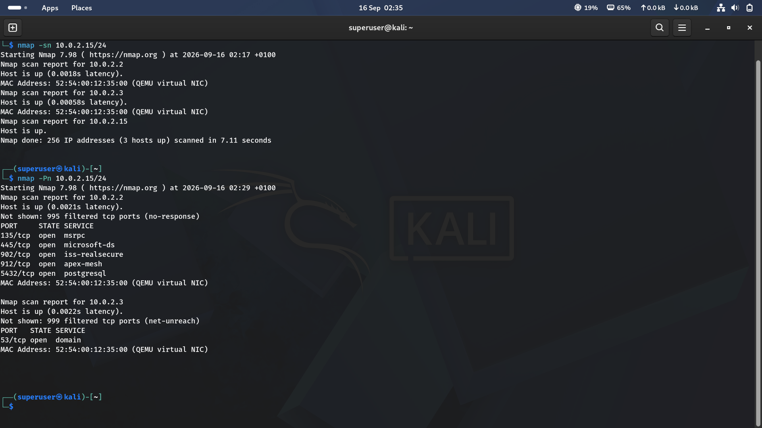
Figure 4 · Ping sweep (-sn) followed by a no-ping scan (-Pn) against the same lab network
Result summary
Host | Open Ports | Notes
10.0.2.2 | 135, 445, 902, 912, 5432 | Same NAT gateway — but only 5 ports open this time (no 3000 or 8090), a reminder that ephemeral local services can start and stop between scans
10.0.2.3 | 53 (domain) | NAT DNS relay, consistent with every earlier scan of this host

My observation
-sn answers “who's alive?” without touching ports. -Pn answers “what's open?” without trusting the ping step — use it against firewalled or ICMP-blocking targets where a normal scan might falsely report the host as down.

3b Enumerating Targets Only (-sL / List Scan)
$ nmap -sL 10.0.2.0/24
What I learned
-sL goes a step further than -sn: it doesn't send a single packet to any target. It simply expands the target specification into a full list of addresses and attempts a reverse-DNS lookup on each one — nothing more. No ping, no ARP, no ports. It's the safest possible way to sanity-check what a CIDR range or target list actually expands to before running anything that touches the network.
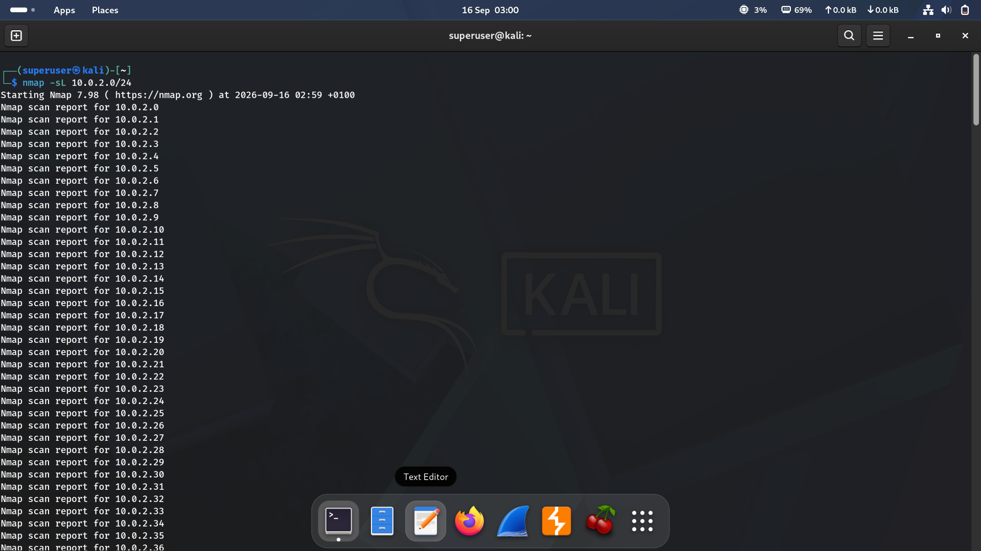
Figure 5 · List scan enumerating every address in 10.0.2.0/24 without probing any of them
Result summary
Aspect | Observation
Addresses listed | All 256 addresses in the /24, from 10.0.2.0 through 10.0.2.255, printed sequentially
Reverse DNS | None resolved for the visible range — expected, since this is a private NAT subnet with no PTR records configured
Host status | Not reported at all — unlike -sn or a full scan, -sL never determines whether a host is up

My observation
Think of these three as a spectrum of how much a scan touches the network. -sL touches nothing — pure enumeration, zero packets sent. -sn touches the network lightly, just enough to ask “is anyone home?” -Pn touches it the most among these three, skipping the ask-first step and probing ports on every address regardless. Use -sL first when I just want to preview or double-check a target range — for example, confirming a /24 really does expand to the 256 addresses I expect — before committing to any live scan.

4 Verbose Scan & Timing Behaviour
$ nmap scanme.nmap.org
What I learned
Running a scan against Nmap's public test host, scanme.nmap.org, surfaces the scan phases and timing engine that are normally hidden in quiet output. Three phases run in sequence: DNS resolution, a quick ping scan to confirm the host is up, and finally the full SYN stealth scan across 1000 ports.
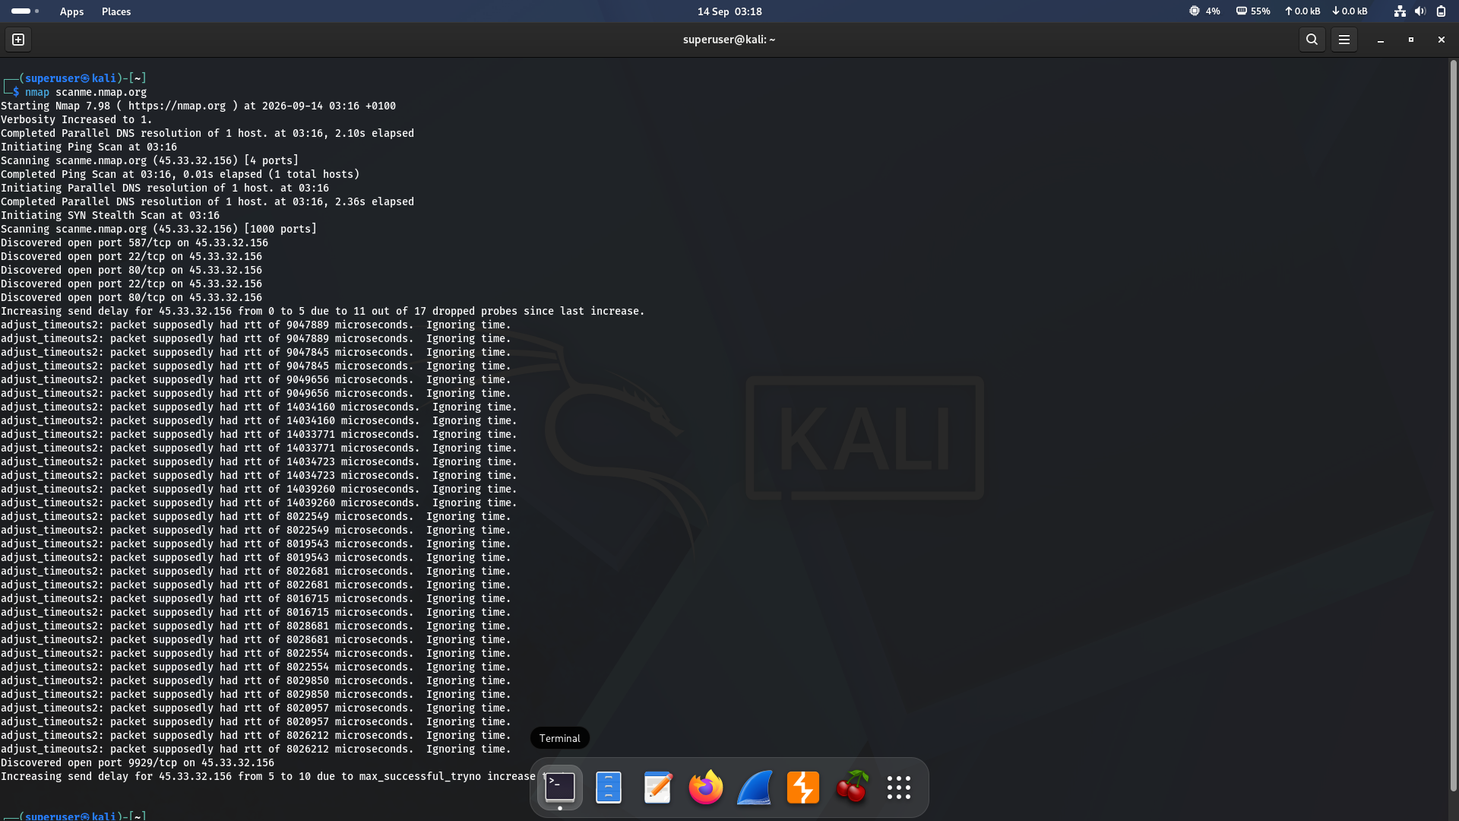
Figure 6 · Scan phases and adaptive timing against scanme.nmap.org
Result summary
- DNS resolution — scanme.nmap.org resolved to 45.33.32.156 before any probing started.
- Ping Scan — a quick host-discovery pass confirmed the target was up (1 host, 4 ports probed) before committing to a full port scan.
- SYN Stealth Scan — the main 1000-port probe. Ports 22, 80, 587 and later 9929 were discovered open.

My observation
The repeated ‘adjust_timeouts2’ lines show Nmap's round-trip-time estimator reacting to inconsistent or dropped responses over the internet link (as opposed to the near-zero latency of the local lab network in Section 3). The first jump — send delay increased from 0 to 5 — was explicitly triggered by packet loss: 11 of the last 17 probes were dropped. The second jump, from 5 to 10, was logged as triggered by a rising successful-try count rather than fresh drops. Either way, this is built-in congestion-control behaviour, not an error. Scans against real internet hosts are noisier and slower than scans on a local subnet, and Nmap's timing engine, not a fixed delay I set, adapts automatically to keep the scan reliable.

5 Key Takeaways
- A bare IP, hostname, list of targets, or CIDR block are all valid ways to specify what Nmap scans — the syntax scales from one host to a whole subnet.
- Filtered vs. closed vs. open all mean different things: filtered = no response (likely firewalled), closed = host responded but nothing is listening, open = a service is listening.
- Shared MAC addresses across ‘different’ hosts is a strong signal you're looking at virtual NAT infrastructure, not distinct machines.
- Nmap's timing/retransmission engine self-adjusts based on real network conditions — this is normal and expected on higher-latency or lossy links.
- -sn (ping sweep) skips port probing entirely, so it's the fastest way to find live hosts on a subnet before running a full, targeted port scan on just those hosts.
- -Pn skips the opposite step — host discovery — and scans ports on every target regardless of ping response, which is essential against hosts that silently drop ICMP probes.
- -sL sends zero packets to any target — it only enumerates the address list and attempts reverse DNS, making it the safest way to preview a range before scanning it for real.

